**ASSIGNMENT 24.6:**

Create a table named temperature with columns weather station, date and temperature. Then load the data into the table and display the contents of the table.

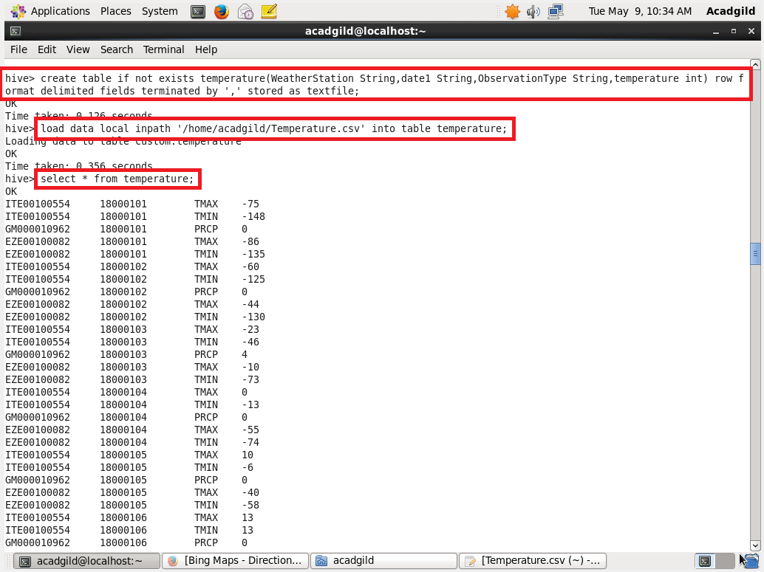

**QUESTION 1:** Write a hive query to find the minimum temperature observed in a given weather station in a particular year.

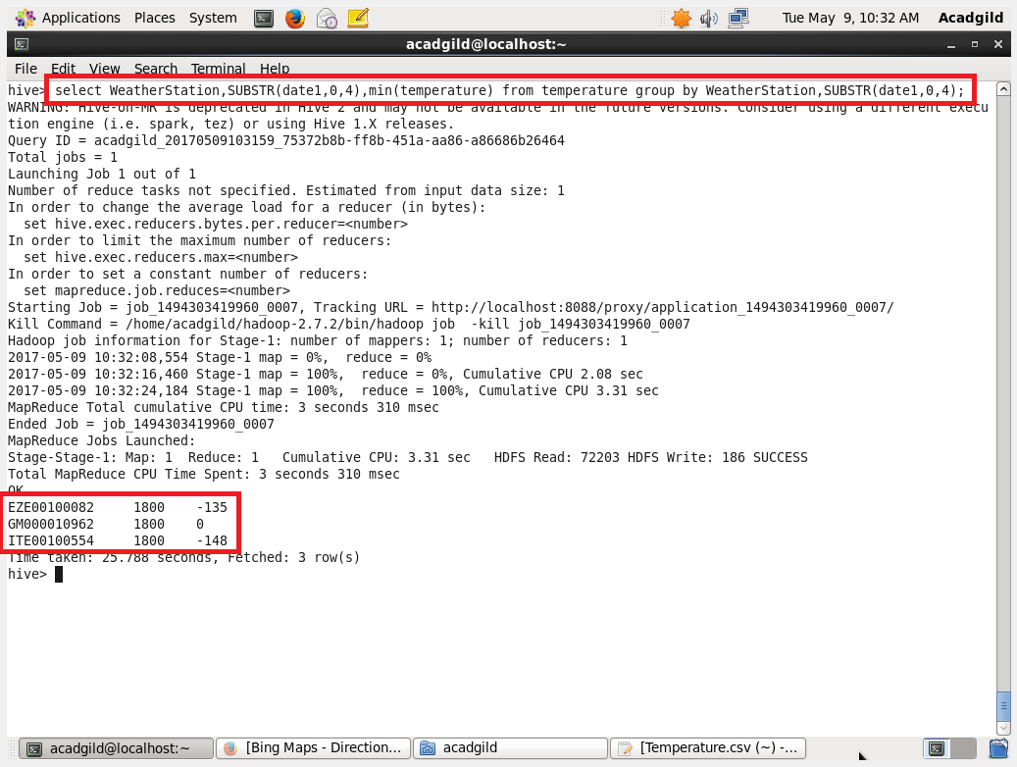

**QUESTION 2:** Write a hive query to find the maximum temperature observed in a given weather station in a particular year.

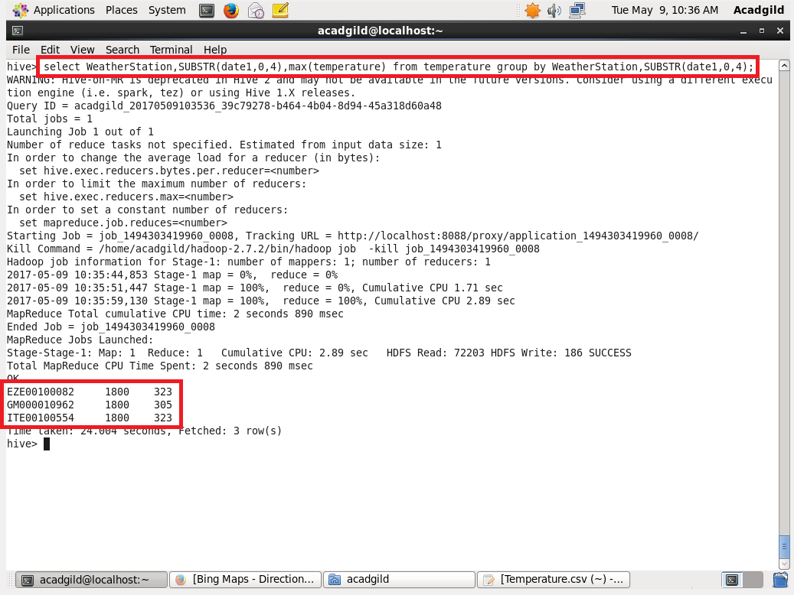

**QUESTION 3:** Write a hive query to find the number of readings given by each weather station according to the dataset.

